Assignment IV: Ray Tracing :)

Prepared by: Siddhartha Shankar Das

Submission Deadline: 22 July, 11.00am

In this assignment you will have to generate realistic image for common shapes like the picture below.

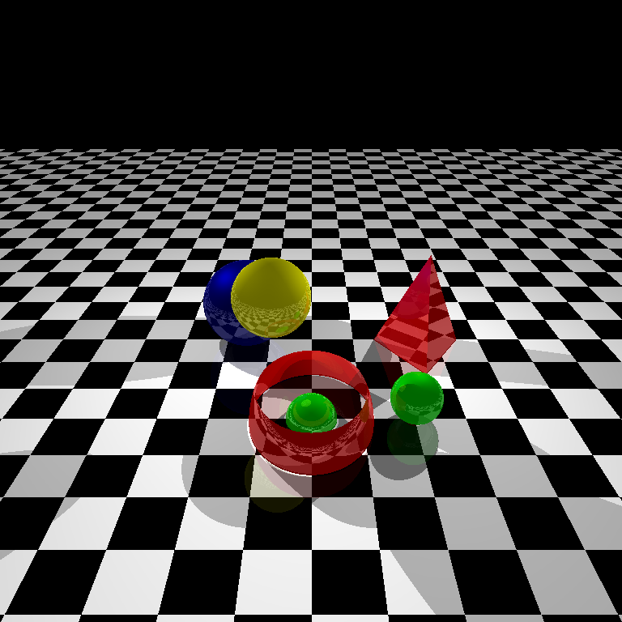

Please check the attached **OpenGl.exe** and **scene.txt** file for better understanding of the mechanism.

<https://drive.google.com/open?id=1nV3nJvYxaHfR73FBE21-JlN-W7cnw0QE>

The scene.txt file contains the configuration and also the explanation of each values. [Read that at first].

**Mark Distribution:** As I have mentioned in the class, no partial marking will be given for written code that doesn’t work for this assignment.

<https://docs.google.com/spreadsheets/d/15Ak1ou_XWf7CZHWt14U7ktPMcGmFo-GhA6s20jkrV1I/edit?usp=drive_web&ouid=112792618929603996297>

# Procedure:

Task 1: Control Over Scene

1. First, it is important to make sure that your camera rotation code from assignment1 is fully working.
2. So check it again and make sure you are able to navigate in any position freely.
3. Set your eye, look, up such that you are looking at x-y-z like the following (preferable for testing)
4. cam.set(Point3(0, -200, 10), Point3(0, 0, 0), Vector3(0, 0, 1)) something like this
5. #define your Window_width, Window_height, 500x500 for test case
6. 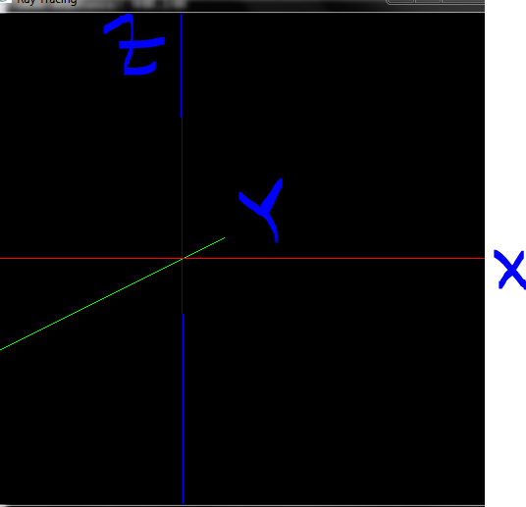

Task 2: Creating Environment

1. In your main function refer to a function loadTestData()

Void loadTestData(){ }

main(){

loadTestData();

//others

}

We will customize the different shape and configuration here for test purposes. Later you have to create a function loadActualData() which will read from the scene.txt file.

2. Create a separate header file/src file with preferable name. Here we will create most of the classes. (You can do everything in same file, but better approach is to module your codes for simplicity). Say here the filename is FILE2, and we have main codes in MAIN_FILE

In FILE2 we will create a Base Class Object with following methods and properties initially. Later you should add and refractor

Object{

Vector3 reference_point;

Double height, width, length;

Int Shine;

Double color[3];

Double co_efficients[4];

Object(){ }

Virtual void draw(){}

Void setColor

Void setShine

Void setCoEfficients

}

And a derived class

Sphere: Object{

Sphere(Center, Radius){

reference_point=Center;

length=Radius;

}

Void draw(){

//write codes for drawing sphere

}

}

3. a) In MAIN_FILE Keep two vectors one for objects and another one for lights and make it accessible to FILE2 too. (just use extern)

Vector <Object> objects;

Vector <Vector3> lights; // or you could just typedef Vector3 to Light for clarity

b) In your loadTestData() function

Object *temp;

temp=new Sphere(Center, Radius); // Center(0,0,10), Radius 10

temp->setColor(1,0,0)

temp->setCoEfficients(0.4,0.2,0.2,0.2)

temp->setShine(1)

objects.push_back(temp);

Vector3 light1(-50,50,50);

lights.push_back(light1);

c) in you display method where

i) Loop over the objects and call draw method

ii) Loop over the lights object and draw Point for each light souce to visualize position

d) Test it.

4. Create a derived class Floor

Floor: Object{

Floor(FloorWidth, TileWidth){

reference_point=(-FloorWidth/2, -FloorWidth/2,0);

length=TileWidth;

}

void draw(){

//write codes for drawing black and white floor

}

}

Now write your draw methods such that it creates a checkerboard of black and white with alternating color on each tileWidth.

Add,

temp=new Floor(1000, 20);

temp->setCoEfficients(0.4,0.2,0.2,0.2)

temp->setShine(1)

objects.push_back(temp)

Test it;

Check it should look Something like the followings

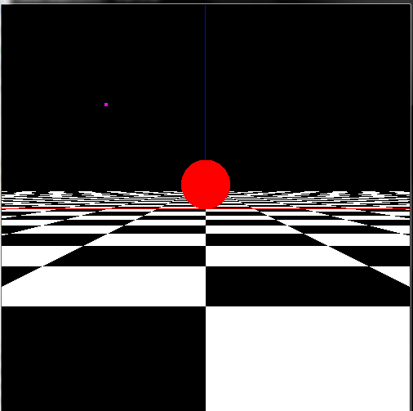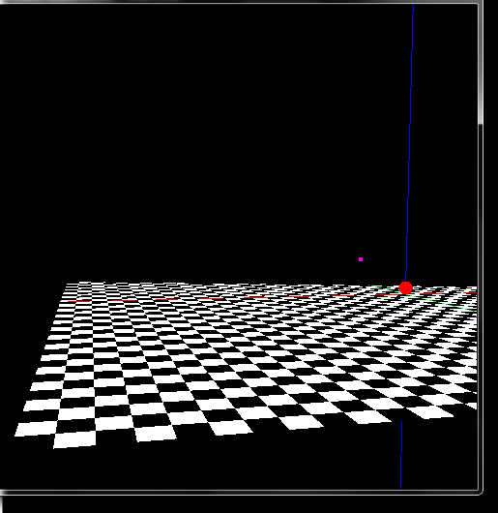

Task 3: Hidden Surface Removal

1. Create a method Capture() in MAIN_FILE which will be called when you press 0
2. In loadTestData() set global variable values for image_width, 768 for test case
3. In FILE2 create a class

Ray{

Vector3 start;

Vector3 dir;

//write appropriate constructor

}

4. Now the pseudocode for intersecting checkings are

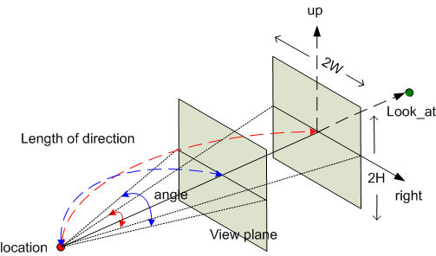

1. capture():

Initalize bitmap_image of image_widthximage_width to black

plane_distance= (window_height/2)/tan(VIEW_ANGLE/2)

**VIEW_ANGLE is your fovy in gluPerspective**

//here l, r, u direction of camera depends on your implementation so use +/- correctly

topleft= eye - l*plane_distance-r*WINDOW_WIDTH/2+u*WINDOW_HEIGHT/2);

du=window_width/image_width;

dv=window_height/image_height;

For i=1:image_width

For j=1:image_width

corner=Find corner point for i, j th pixel using eye similar to topleft above

Create a Ray using (eye, (corner-eye)) //always normalize direction

nearest=-1;

For each object k

t =object[k]->intersect(ray, dummyColorAt, 0)

//dummyColorAt is the color array where pixel value will be stored in return time. As this is only for nearest object detection dummy should be sufficient. Level is 0 here

if(t<=0) continue;

Update t, nearest if t<t_min

End

if(nearest!=-1)

t =object[nearest]->intersect(ray, colorAt, 1)

//in this case we know nearest object so level should be set to 1

//we will deal with this later

Update_image_i_j pixel value

end

End

End

save_image

b) In Object base class create a virtual method intersect

Virtual double intersect(Ray *r, double *current_color, int level){

Return -1;

}

c) Now in Sphere Derived Class override this function

In this function you have to calculate the sphere ray intersection:

Please refer to you ray_casting Slide Page no 31, 32

Here you will find necessary calculation for calculating t

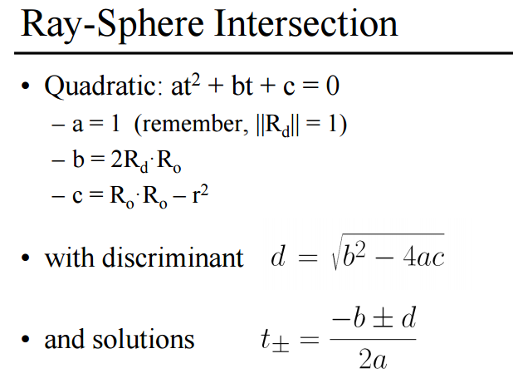

A= dot(ray->dir, ray->dir)

B= from equation

C= from equation

D=B^2-4ac

If D<0 return -1;

Otherwise Calculate t1, t2

Update current_color=color // for the time being testing purpose

Return the minimum t

d) Now test it, Make sure everything working

If everything works then you should see an image with only a circle in it

If it does not work, then in capture function

Set i, j to a specific pixel and check for intersection

Or in intersect function, Set custom Ray->start(0,100,10) and Ray->direction (0, 1, 0)

So for a sphere centered at 0,0,10 with radius 10.

You should get two intersecting point 0,-10,10 and 0,10,10

If works add more sphere and test it, it should work as hidden surface removal procedure

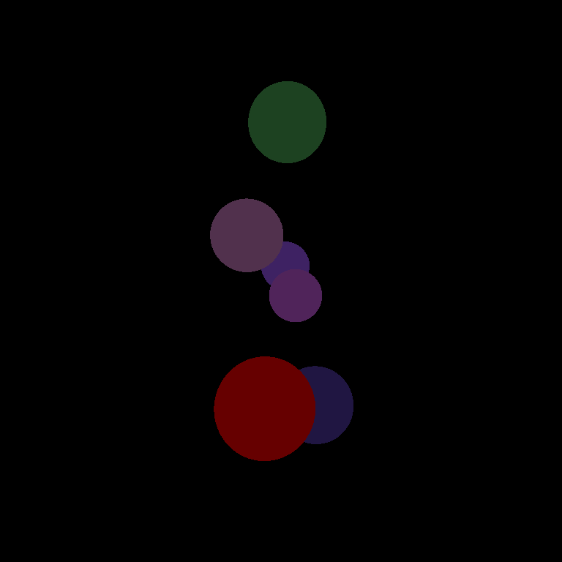

Task 4: Illumination

1. Your hidden surface procedure should be working by now. The next step is to add some lighting. If you look closely, the purpose of level variable in intersecting method is to determine the nearest object. So no color computation actually necessary here.

So after computation of intersecting t in do a simple check like following

If (level==0){

Return t;

}

b) Now if level is not 0 (here 1) then add some lighting codes, and regroup functions like following

So skeleton of your function should look like this

double intersect(Ray *r, double *current_color, int level){

t= getIntersectingT(Ray *r) //perform computation of intersection here

If t<=0 return -1

if(level=0)return t;

intersectionPoint = r->start+ r->direction*t;

colorAt=getColorAt(intersectionPoint)

// generally this function should return single color but for checkerboard like plane color depends on intersectionPoint

setColorAt(current_color, colorAt)

Return t;

}

At setColorAt function multiply each colorAt color value with ambient coefficient

current_color=colorAt*co_efficient[AMBIENT];

Because AMBIENT means how normally illuminated an object is

Test it. You would a an Object getting dimmer shade.

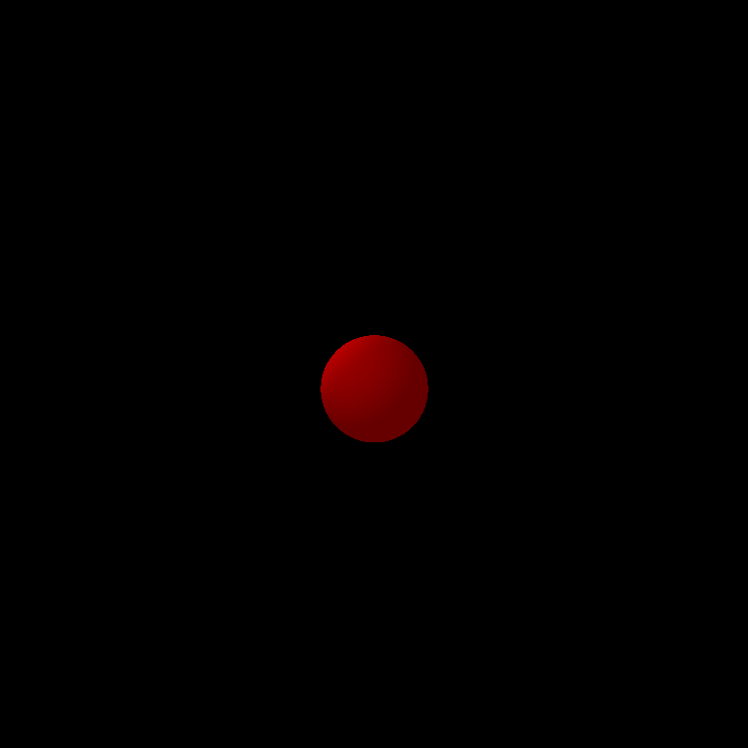

c) After the above step, add the following codes after setColorAt()

normal=getNormal(intersectionPoint);

reflection=getReflection(ray, intersectionPoint);

**to calculate reflection from incident ray at intersectionPoint check the formula

reflection= 2 (ray->direction . normal) normal – ray->rection // may be different for you

Normalize it

<http://asawicki.info/news_1301_reflect_and_refract_functions.html>

d) Now you have to check whether the intersecting point is obscured by any objects from the light 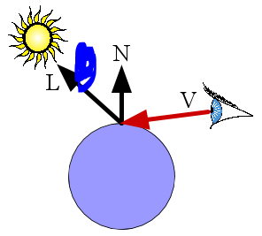

Because if light source is obscured by an object then no impact of light will be

applicable on the intersecting pixel

So after the above part do the following

For each light source

Construct L ray like in the picture

direction= (lightSource-intersectionPoint) //normalize it

start= intersection + direction*1 //1 is for taking slightly above the point so it doesn’t again intersect with same object due to precision

Ray L(start, direction)

For each object now check whether this L ray obscured by any object or not.

If it is not obscured that means light falls onto the intersection point so you have update current_color,

Calculate lambert value,

Calculate phong value

//check the illumination slide for formula

Now update each pixel value of Current_Color by following

current_color+=source_factor*lambert*co_efficient[DIFFIUSE]*colorAt

current_color+=source_factor*pow(phong,shine)*co_efficient[SPECULAR]*colorAt

end

end

**** IF YOU COMPLETE THE ABOVE PART by then you have completed the illumination PART :D So your output should look like following



Task 5: Reflection

1. Reflection means using the reflected ray you do the same as before and how many times you reflect is your Recusion_Level
2. So in MAIN FILE decare global variable recursion_level, make it availble in FILE2 via extern operator and in loadTestData set it as 3 or 4
3. Now after the above code do the following

if(level<recursion_level)

start=intersectionPoint+reflection*1 //slight up to avoid own intersection

Ray reflectionRay(start, reflection)

Like capture method, find the nearest intersecting object, using intersect function

If found

objects[nearest]->intersect(reflectionRay, reflected_color, level+1);

//update curernt_color using reflected_color

current_color+=reflected_color*co_efficient[REFLECTION];

End

End

Check whether all current_color pixel value is within 1 or 0 if not set it

****** If you complete the above step then for multiple sphere you output should look like the following

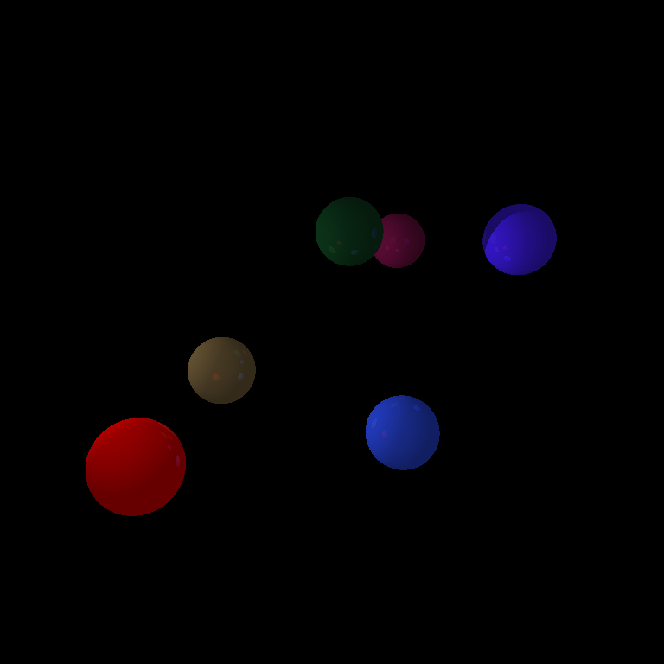

Task 6: Floor , Triangle

Ok now, if you complete up to this part, clearly you can now see that the differences between Sphere, FLOOR, Triangle are

getNormal(), getColorAt(), getIntersectingT() these functions.

So, You Should make appropriate virtual functions and derived methods for handling these

1. For FLOOR,
   1. the normal will be always 0,0,1
   2. For t calculation of plane, you can use the equation from slide or other ways.

After finding t, calculate the intersectingPoint

If the point is not within the floor then return -1

iii) At getColorAt(intersection) check on which tile the intersection point belongs and return color accordingly

b) For triangle normal calculation

normal= (b-a) X (c-a)

Intersection formula, you can use slides formula or from the following link

<https://en.wikipedia.org/wiki/M%C3%B6ller%E2%80%93Trumbore_intersection_algorithm>

If you complete this then you have Basic RayTracing

Task 7: General Quadratic

1. If you check the following Link

<http://tutorial.math.lamar.edu/Classes/CalcIII/QuadricSurfaces.aspx>

general Quadratics have following form



b) If you done everything, then you know

The only change is getIntersectingT() and getNormal()

<https://drive.google.com/drive/folders/12ura3BBQ8Rerl0E-ZXtqLgjfs_mHWrt1>

Class lecture

i) First, getNormal(intersectionPoint)

Normal vector for the above form will be

(dF/dx , dF/dy, dF,dz)

So find each of them, substitute x, y, z values of intersectionPoint to get Normal

ii) forGetIntersectionT (Ray *r)

You have x= x0+ tx1, y=y0+ty1, z=z0+tz1

Therefore, if you substitute these then you will find

Equation of form

At^2 + Bt+ C =0

Like sphere now you can calculate t1 and t2

c) Clipping :

Now from the t1 and t2

Calculate intersecting_point1 and intersecting_point2

If both point within volume return smallest t

If only one then return that

If none return -1

Task 8 : LoadActualData

1. load Actual information from scene.txt file
2. display



Task 9: Refraction

Do refraction only for one or two sphere objects.

Set eta or refraction index according to your preference.

Some, Ray calculation and other related calculation can be found here

Codes are given here:

<https://graphics.stanford.edu/courses/cs148-10-summer/docs/2006--degreve--reflection_refraction.pdf>

<https://drive.google.com/drive/folders/12ura3BBQ8Rerl0E-ZXtqLgjfs_mHWrt1>

<http://asawicki.info/news_1301_reflect_and_refract_functions.html>

The calculations and after processing are quite similar to reflection, therefore you should be able to do that by some searching.

Task 10: Simple texture at floor

Load any picture of any suitable dimension ( Eg. 500 x 500).

Map this picture to the floor dimension.

Multiply the floor pixel color with image pixel color to view the texture image combined with the floor.

In this assignment, you will have to handle texture for floor and a rectangle image ( :D ).

Task 11: Clear Memory

1. Free objects, images, lights and other memories

# Do’s and Don’ts:

* Think yourself twice about the problems first then contact me if requires
* Do not copy codes, not from your friends, previous years or online. Write it yourself
* Start couple of days earlier because there are many things that can go wrong
* Test your code, and do program incrementally
* I will be very busy in the following couple of weeks, thus look up on the internet first for any issues.

### Marks Distribution:

<https://docs.google.com/document/d/1AvSleiIJT9Gac1lzj6UxHhULInLfG5snto6bo7tzEkQ/edit?usp=sharing>

|  |  |  |  |  |  |  |  |  |  |  |
| --- | --- | --- | --- | --- | --- | --- | --- | --- | --- | --- |
| **ID** | **Submission** | **Task 3**  **HSR** | **Task 4**  **Illumination** | **Task 5**  **Reflection** | **Task 6**  **Floor, Triangle** | **Task 7**  **General Quad** | **Task 8**  **File Loading** | **Task 9**  **Refraction** | **Task 10**  **Texture** | **Total** |
| 1305xxx | 10 | 15 | 15 | 20 | 10 | 15 | 5 | 5 | 5 | 100 |
|  |  |  |  |  |  |  |  |  |  |  |
|  |  |  |  |  |  |  |  |  |  |  |
|  |  |  |  |  |  |  |  |  |  |  |
|  |  |  |  |  |  |  |  |  |  |  |
|  |  |  |  |  |  |  |  |  |  |  |
|  |  |  |  |  |  |  |  |  |  |  |